REPORT
E.C. Orientation on Startup and Innovation 2023
On the day of 5th May, 2023, Session on Orientation of startup and innovation for 1st year and 2nd year E.C students was held in room no 968 of EC building at 11.30 am. The aim of orientation was to make 1st and 2nd year students aware about SSIP 2.O policy and encourage them on why to choose startup. HOD Dr. C. H. Vithlani, SSIP Coordinator, Dr. Manish Thakkar, Dr. Sanjay Prajapati, IPR and Research coordinator along with department SSIP coordinator Dr. Nirali Kotak were present. Total 122 students have attended the session.
The orientation was started by a brief introduction about startup and entrepreneurship by hosts. The introduction contained the basics of startup and terms like pre-incubation.
After that HOD sir, gave his wise words to student about SSIP policy and about how they could utilize time making it worth. Further he spoke about importance of startup and the environment that is being provided to the students. He also highlighted about benefits of moving to entrepreneurship at a young age.
Then Dr. Manish Thakkar sir has motivated students in the direction of entrepreneurship and startups.
After that department SSIP coordinator, Dr. Nirali Kotak walked through the steps to file a PoC and how the given Ideas will be evaluated, the financial allowance for innovation, mentor allowance and other supports.
As concluding remarks, Dr. Sanjay Prajapati sir has encouraged students regarding IPR facilities and opportunities provided by the institute for filing patents, copy rights, trademarks, industrial design and semiconductor design as well.
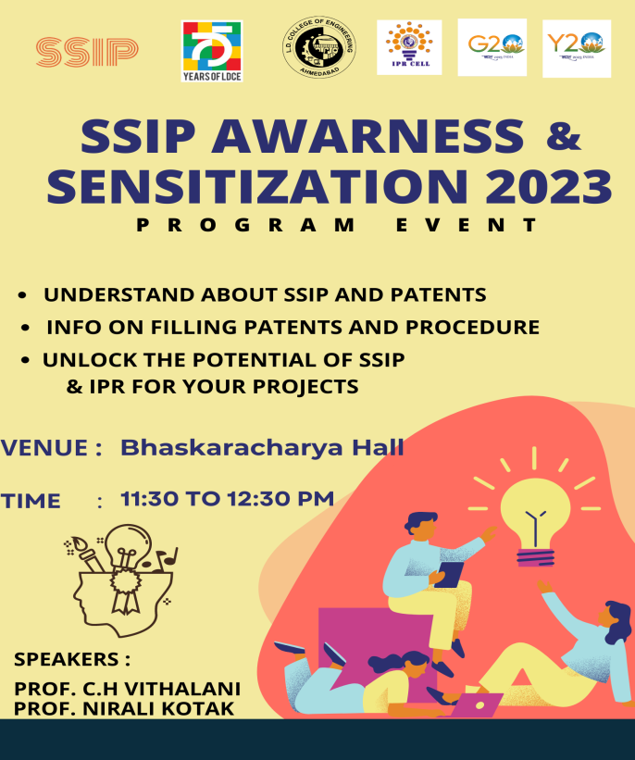 | 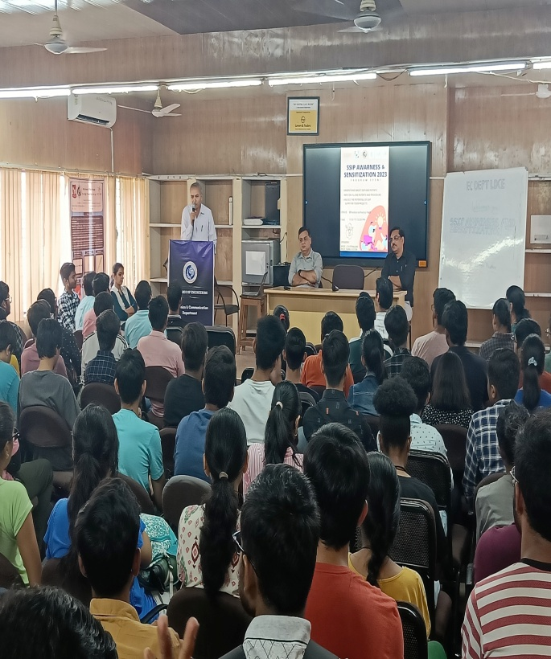
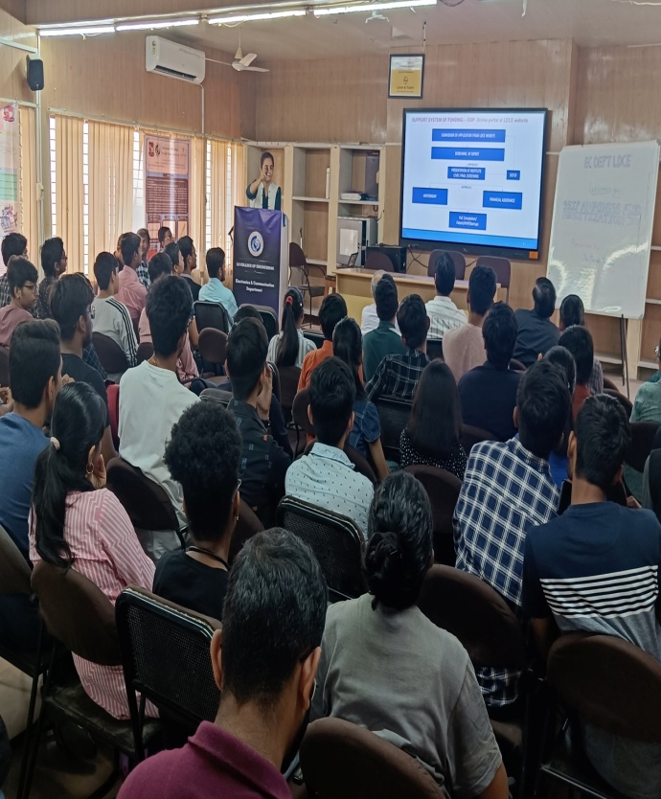 | 